- The slight softening in UK CPI inflation in May reflected a fall in services inflation, as the Office for National Statistics corrected April's vehicle exercise duty error and the Easter jump in air fares unwound. We expect inflation to edge up in the short-term, peaking in September, but a drop in the contribution from the energy category should see inflation cool from the autumn.
- The vehicle excise duty correction means the services category should offer slightly less support over the next year than previously thought. We have also taken on board a stronger outlook for fuel prices due to heightened tensions in the Middle East. These offsetting changes leave our annual CPI forecast unchanged at 3.3% in 2025 and 2.5% in 2026.
CPI inflation fell fractionally to 3.4% in May, from 3.5% in April. The modest decline was the result of a smaller contribution from the services category. In part, this reflected the Office for National Statistics correcting an error in the vehicle excise duty sub-category that had meant it had overstated April's increase. There was also some downward pressure from the air fares sub-category in May, with the timing of the Easter holidays having temporarily boosted April's outturn. May's fall in services inflation was more than enough to offset modest rises in the food and core goods categories. RPI and RPIX inflation edged down to 4.3% and 4.1% respectively, from 4.5% and 4.2% in April.
Looking ahead, we expect headline inflation to rise gradually in the coming months, and peak in September. But from the autumn, inflation is likely to cool as the positive contribution from the energy category disappears, which should outweigh the impact of sticky services inflation.
The ONS' correction in the vehicle excise duty sub-category means we now think the services category will offer slightly less support to inflation over the next year than we did previously. However, we have also incorporated a slightly stronger near-term outlook for fuel prices into our forecast, following an escalation in Middle East tensions. The offsetting nature of these changes means our annual CPI inflation forecast remains at 3.3% this year and 2.5% in 2026.
Chart 1: We still forecast CPI inflation to average 3.3% this year and 2.5% in 2026
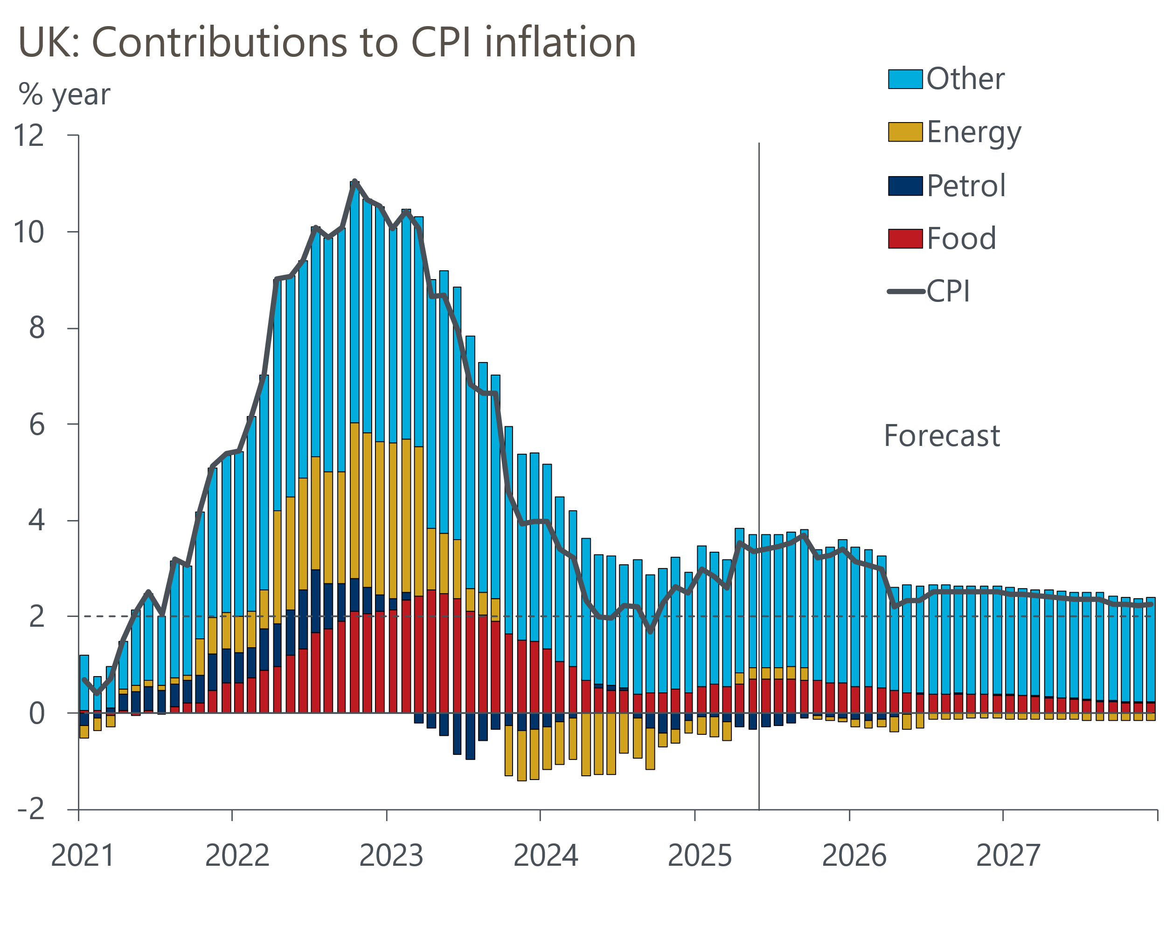
Source: Oxford Economics, Haver Analytics

